

Aldabra Research Station

Research Officer’s Annual Report

2009

Compiled by: Naomi Doak

Contents

Contents 2
1.0: Summary 2
2.0: Climate 4
3.0: Turtle Monitoring 6
3.1: Track counts along external beaches (Green turtles) 6
3.2: Track counts along lagoon beaches (Hawksbill turtles) 7
3.3: Tagging of Nesting Turtles 7
3.4: Tagging of juvenile turtles 7
4.0: Aldabra Tortoise Monitoring Programme 7
4.1: Introduction 7
5.0: Bird Monitoring 14
5.1: Land birds 14
5.2: Wader counts 17
5.3: Sea birds 17
6.0: Subsistence Fishing 19
7.0: Robber Crabs 20
8.0: Marine Mammals 20
8.1: Dugongs 20
8.2: Whales and dolphins 20
9.0: Vegetation Monitoring 20
10.0: Goat Eradication Project 20
11.0: Rangers Projects 21
12.0: Departmental Issues 21
12.1: Staff 21
5.0: Comments from RO 21

1.0: Summary

Figure 1: Map of Aldabra Atoll with camps and locations of monitoring transect/activities.

2.0: Climate

Table 1: Mean monthly temperatures for 2009, Picard weather station.
 | Jan | Feb | Mar | April | May | June |  | July | Aug | Sep | Oct | Nov | Dec
dry bulb | 29.2 | 28.7 | 18.7 | 19.4 | 18.2 | 17.8 |  | 15.8 | 16.2 | 16.8 | 18.7 | 19.58 | 20.1
wet bulb | 26.8 | 26.6 | 26.5 | 27.0 | 26.5 | 25.6 |  | 24.1 | 24.0 | 24.4 | 25.6 | 27.04 | 28.2
mean daily max | 32.1 | 31.9 | 33.3 | 33.0 | 31.6 | 29.7 |  | 28.2 | 28.7 | 29.6 | 29.6 | 33.0 | 33.2
mean daily min | 23.7 | 24.4 | 23.5 | 19.7 | 15.0 | 14.5 |  | 15.6 | 15.6 | 16.3 | 19.4 | 15.45 | Na
max daily maximum | 35.0 | 35.0 | 34.5 | 34.5 | 33.0 | 31.5 |  | 31.2 | 30.0 | 30.6 | 31.0 | 34.0 | 35.6
2008
mean max | 35.5 | 35.5 | 35.5 | 32.8 | 31.5 | 29.5 |  | 28.6 | 28.5 | 29.6 | 30.6 | NA | 33.2
Max daily maximum | 35.8 | 35.5 | 35.5 | 35.5 | 31.6 | 33.0 |  | 33.0 | 29.5 | 30.6 | 32.1 | NA | 34.8

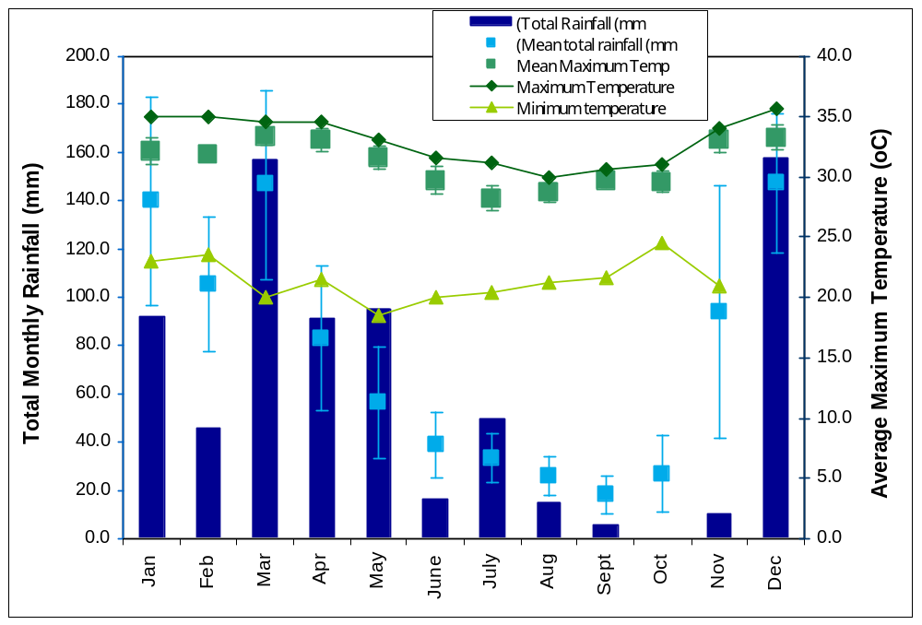
Figure 2: Total Monthly Rainfall and Average Maximum Temperature for Picard, Aldabra (± SE).

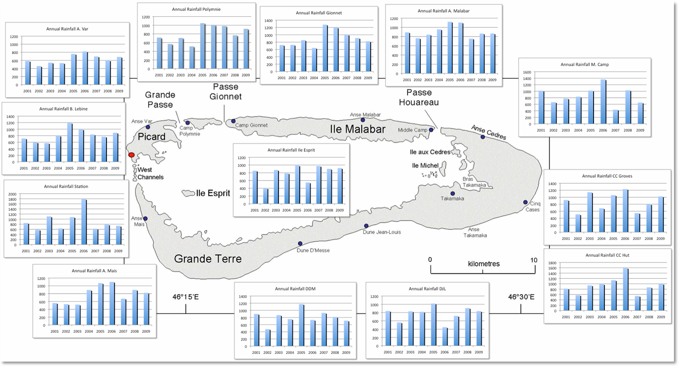

Figure 3: Total annual rainfall 2001 – 2009 for the rain gauge locations around the atoll.

3.0: Turtle Monitoring

3.1: Track counts along external beaches (Green turtles)

Table 6: Turtle tracks observed on Settlement Beach, Picard
 |  | Jan | Feb | Mar | Apr | May | June | July | Aug | Sept | Oct | Nov | Dec | Total
Zone 1 | VF | 3 | 15 | 8 | 6 | 13 | 22 | 17 | 10 | 3 | 4 | 6 | 16 | 123
 | HM | 0 | 1 | 1 | 1 | 2 | 1 | 2 | 1 | 1 | 0 | 0 | 1 | 11
 | ESBO | 0 | 0 | 0 | 0 | 0 | 1 | 1 | 0 | 0 | 0 | 0 | 1 | 3
Zone 2 | VF | 41 | 49 | 44 | 96 | 96 | 133 | 110 | 122 | 79 | 18 | 26 | 39 | 853
 | HM | 1 | 3 | 2 | 7 | 1 | 4 | 8 | 1 | 3 | 1 | 3 | 3 | 37
 | ESBO | 1 | 3 | 0 | 1 | 2 | 0 | 0 | 0 | 0 | 1 | 0 | 4 | 12
Zone 3 | VF | 44 | 58 | 98 | 110 | 139 | 134 | 128 | 120 | 70 | 49 | 17 | 37 | 1004
 | HM | 2 | 6 | 5 | 10 | 7 | 8 | 12 | 4 | 0 | 2 | 5 | 4 | 65
 | ESBO | 5 | 4 | 7 | 11 | 5 | 5 | 3 | 5 | 3 | 0 | 4 | 7 | 59
Zone 4 | VF | 71 | 117 | 214 | 244 | 233 | 207 | 153 | 102 | 96 | 77 | 22 | 31 | 1567
 | HM | 1 | 7 | 15 | 14 | 10 | 12 | 11 | 12 | 3 | 6 | 2 | 5 | 98
 | ESBO | 9 | 16 | 28 | 51 | 47 | 54 | 45 | 38 | 29 | 20 | 13 | 7 | 357
Total |  | 178 | 279 | 422 | 551 | 555 | 581 | 490 | 415 | 287 | 178 | 98 | 155

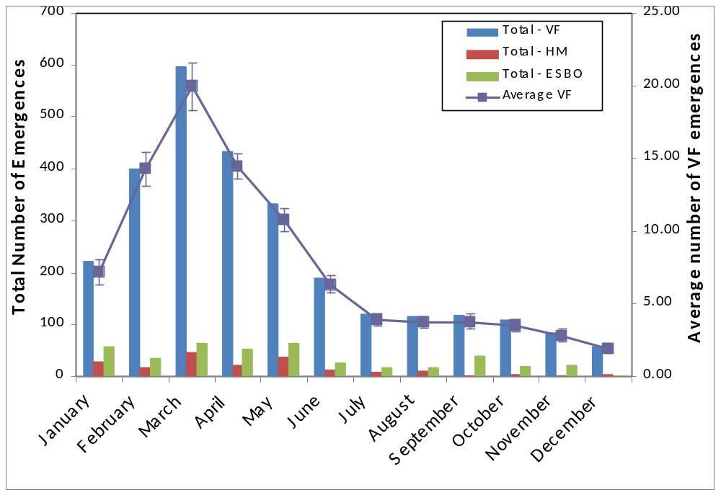

Figure 4: Average monthly number of very fresh (VF) emergence tracks recorded in each beach Zone on settlement beach in 2008 (± SE).

Table 7: Mean monthly number of turtle tracks observed for all beaches around the Atoll
 | Jan | Feb | Mar | Apr | May | June | July | Aug | Sept | Oct | Nov | Dec
Settlement | 5.1 | 8.2 | 11.7 | 15.2 | 15.5 | 16.5 | 13.2 | 11.4 | 8.3 | 4.8 | 2.4 | 4.0
West Grande Terre¹ | 18.0 | 35.8 | 43.5 | 56.0 | 71.3 | 92.0 | 71.3 | 44.0 | 43.0 | 15.0 | 11.0 | 23.0
Dune D’Messe² | 3 | 1.5 | 6 | 3 | 1 | 4 | 0 | 0 | 0 | 1 | 2 | 0
Dune J-L³ | 5 | 11 | 21 | 19 | 24 | 30 | 17 | 17 | 6 | 4 | 6 | 3
Cinq Cases⁴ | 0 |  |  | 1 | 1 | 0 | 0 | 0 | 0 | 0 | 0
North⁵ | 6.5 | 2.5 | 15 | 17 | 21 | 22 | 10 | 17 | 12 | 3 | 1 | 1
Anse Var⁶ | 0.5 | 0 | 0 | 0 | 1 | 0 | 0 | 1.5 | 0 | 0 | 0 | 0
¹ Beaches included in count – 2,3,4,5,6,7,8,9,10,11,12,13,14,15,15.5,16,17,17.5,18,19,20,21. FF tracks not recorded.
² Beaches included in count – 23, 24, 25, 26, 27, 28.
³ Beaches included in count – 29, 30, 31, 32, 33, 34, 35, 36. FF only recorded on 29, 30, 31.
⁴ Beaches included in count – 37, 38, 38.5, 39. FF not recorded.
⁵ Beaches included in count – 40, 41, 42, 43, 43.5, 44, 45, 46, 51, 55. FF only recorded on 40, 41, 42, 43. Anse Var included
⁶ Beaches included in count – 55 only. Anse Var counted in North beach counts as well as in its own count.

3.2: Track counts along lagoon beaches (Hawksbill turtles)

3.3: Tagging of Nesting Turtles

3.4: Tagging of juvenile turtles

4.0: Aldabra Tortoise Monitoring Programme

4.1: Introduction
Data, including the size, sex and abundance along designated transects, for the giant tortoises has been collected since 1998 on Aldabra. There are 12 transects located around the atoll (Figure 1) and while in total this covers only a very small percentage of the area of the atoll it provides information on the status of the population and covers the major habitat types found on all 4 main islands that make up the atoll. While the relatively small percentage of area covered has been criticised in the past logistical constraints render increasing the number and thus area covered by such transects impractical and the 12 transects currently monitored provide an indication of population status and trends.

The transects are monitored when possible on a monthly basis providing valuable information on the population size, structure and distribution of this species around the atoll. It also allows for annual and monthly variations in these parameters to be investigated with the continued monitoring adding to a valuable long term programme focused on this species.

There are currently two models used to look at the population of tortoises on the atoll; Bourns’ and Rainers’. Both of these require updates to the files and links used for the final calculations before results can be presented. This will be worked on for the 2009 annual report and is commented on in the RO comments for this report. Results presented below are summary results from the four main areas of the atoll where transects are located; Picard (3 transects), Cinq Cases (3 transects), Malabar (3 transects) and Grande Terre (3 transects).

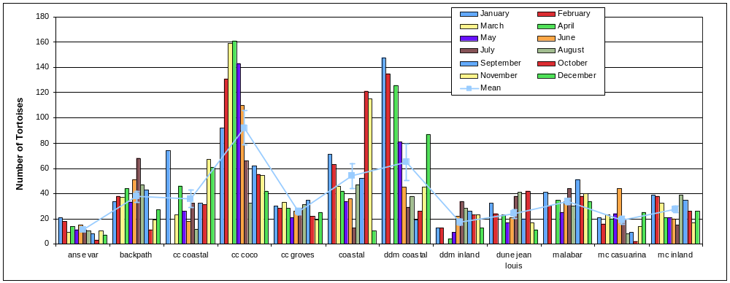

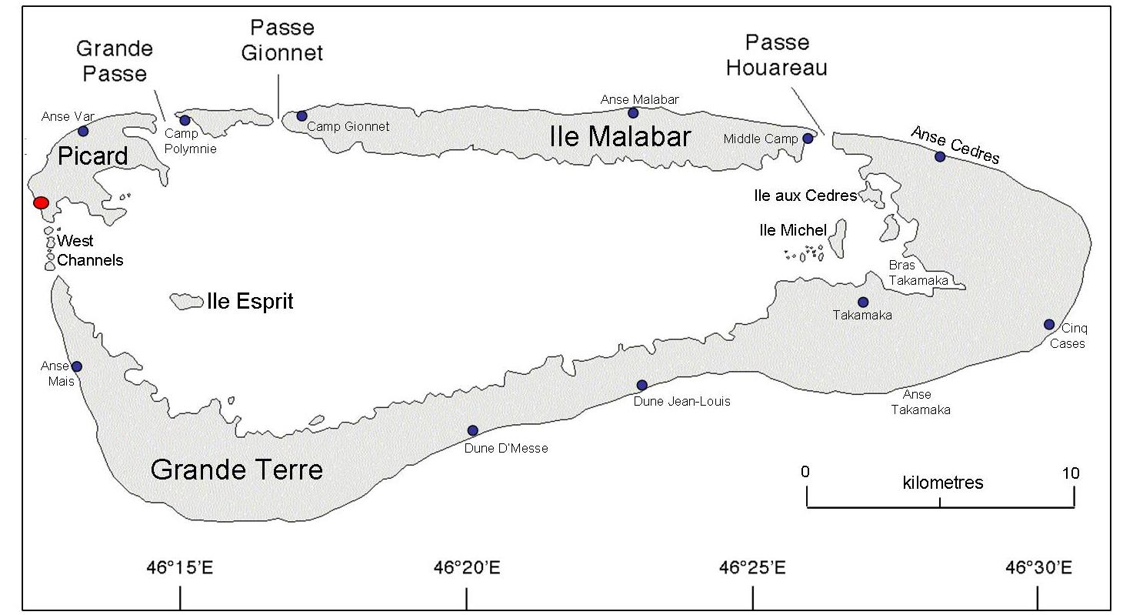
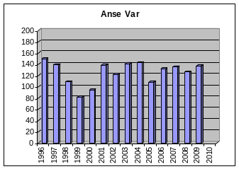
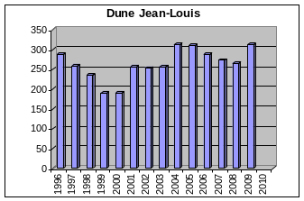
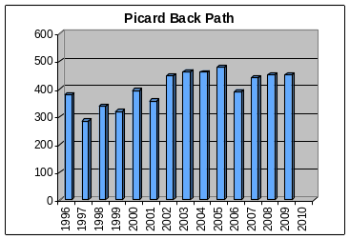
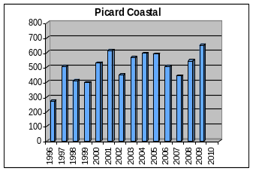
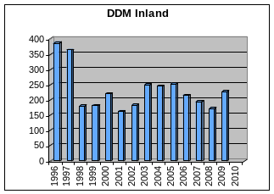
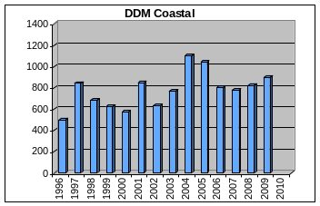
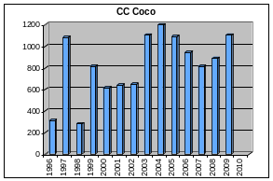
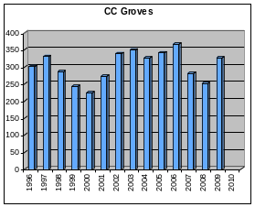
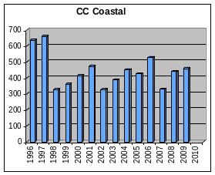
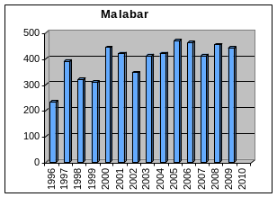
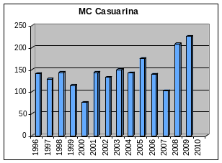
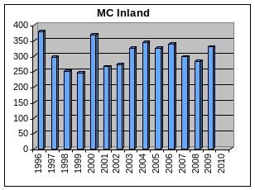

Picard
Tortoise monitoring was conducted on Picard for all three transects once each month. Anse Var consistently records the lowest number of tortoises along the transect and individuals in this part of Picard are on average smaller than those detected on the other two transects, Coastal and Back Path (Figure 5). While the coastal transect often records a higher number of individuals it should be noted that the width of this transect is 20 m (10 m on each side of the transect) while for all other tortoise monitoring transects on Aldabra the width is 10 m (5 m on each side of the transect). This will not only influence the number of individuals recorded but also the mean size as the increased sample size will influence the calculation of the mean and any variation around this.
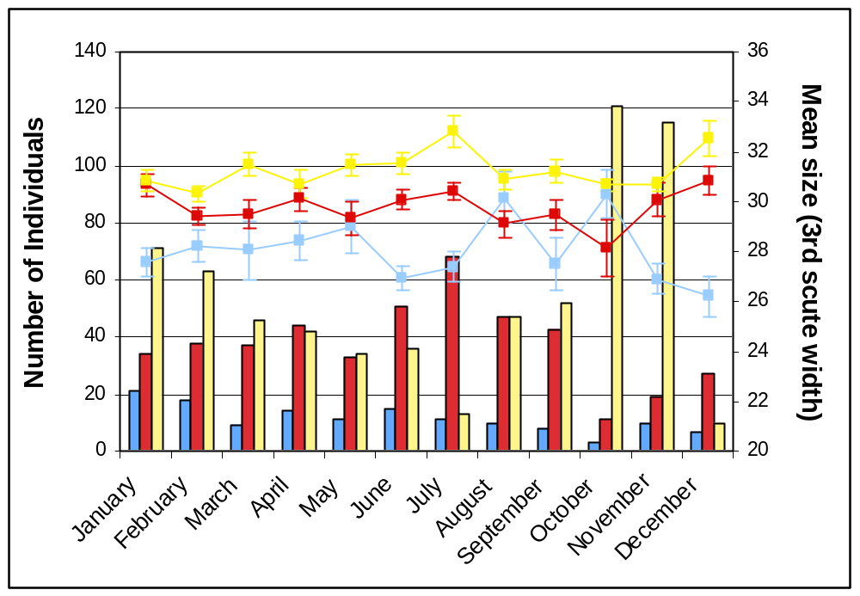
Anse Var
Picard Backpath
Picard Coastal
Figure 5: Number of individuals (columns) and mean size (line) as determined by the width of the third scute for the three giant tortoise transects monitored at Picard.

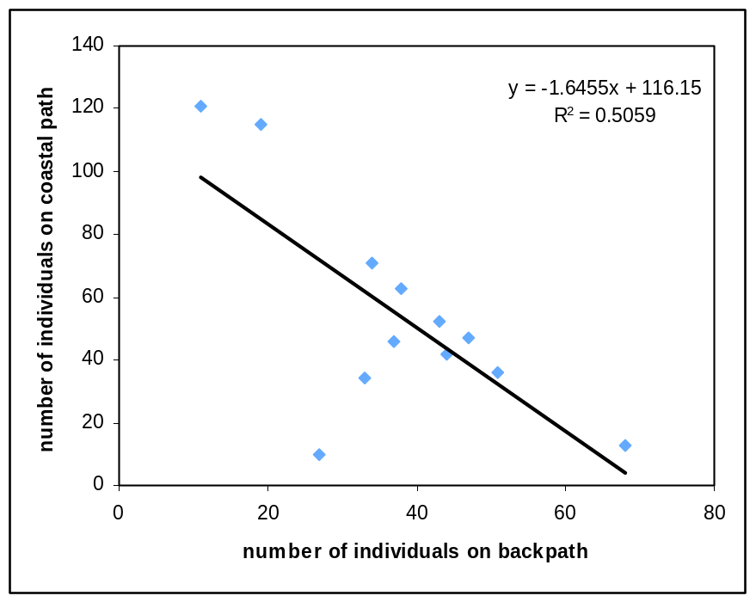

Malabar
Tortoise monitoring was completed at the three transects on Malabar each month of 2008. The coastal transect at Middle Camp consistently records the lowest number of individuals of all three transects while the transect at Malabar camp records the highest number of individuals and individuals with the highest mean size. Despite the Malabar transect recoding the highest number of animals, these numbers were mostly below the numbers recorded on Picard and the mean size was also smaller than those recorded on any of the three transects on Picard.

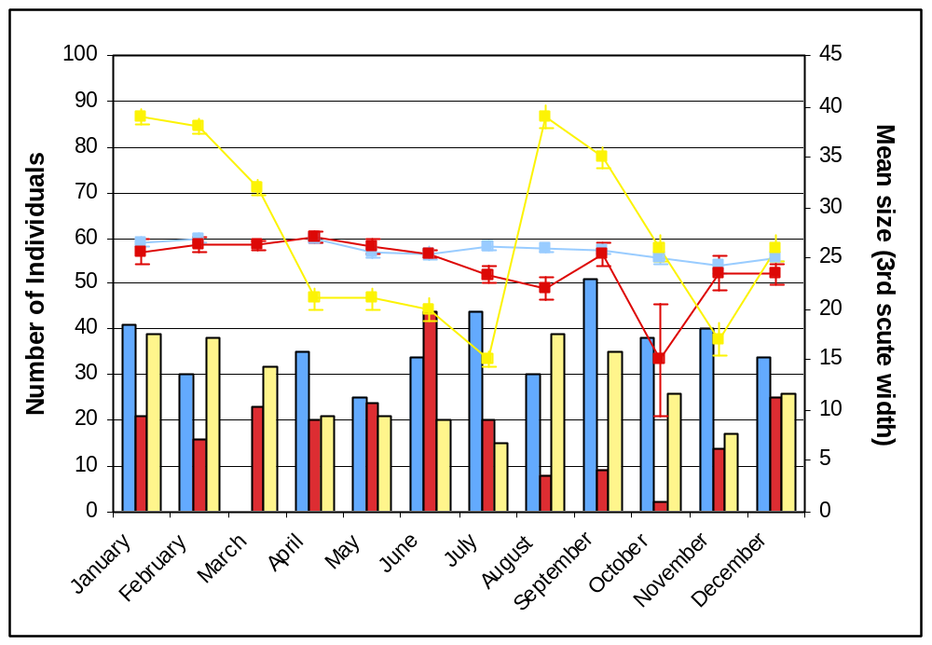
Figure 6: Number of individuals (columns) and mean size (line) as determined by the width of the third scute for the three giant tortoise transects monitored on Malabar.

Grand Terre – Cinq Cases, Dune Jean Louis, Dune D’Messe
Historically monitoring of the giant tortoise population on Aldabra has shown that the area around Cinq Cases on Grande Terre has the highest number of individuals and these tend to be of a smaller size than in many of the other areas of the atoll. The data collected on all transects on Grande Terre during 2008 showed the same trends with the transect at Cinq Cases Coco and Dune D’Messe Coastal consistently recording the largest number of individuals. All 6 transects on Grande Terre recorded individuals of a much smaller size than those recorded on the transects on Picard and also Malabar. Individuals on the Cinq Cases Groves transect tended to be the smallest of any transect with many of these individuals falling under the size threshold used for determining the sex of individuals. In some locations this threshold perhaps needs reviewing and reconsidering and sexing of individuals in these locations where most animals are under the 20cm threshold should also be attempted and recorded where possible to obtain estimates of the sex ratios of the local populations in these areas.

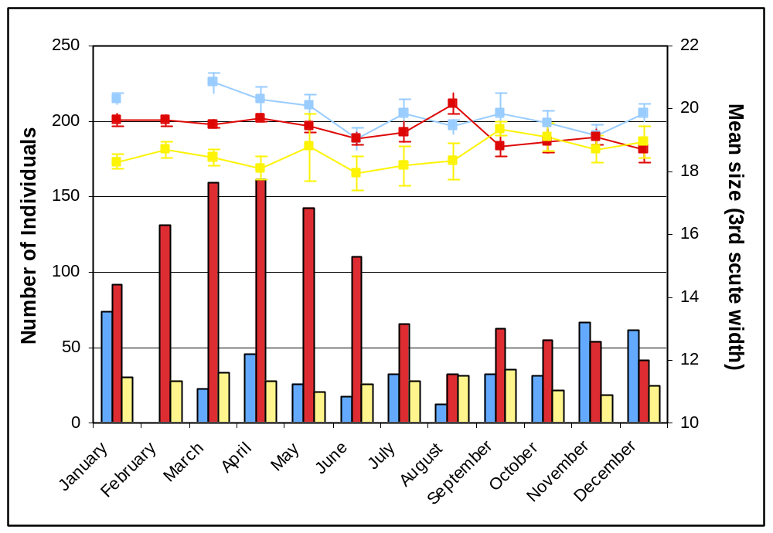
Figure 7: Number of individuals (columns) and mean size (line) as determined by the width of the third scute for the three giant tortoise transects monitored on Grande Terre, Cinq Cases.

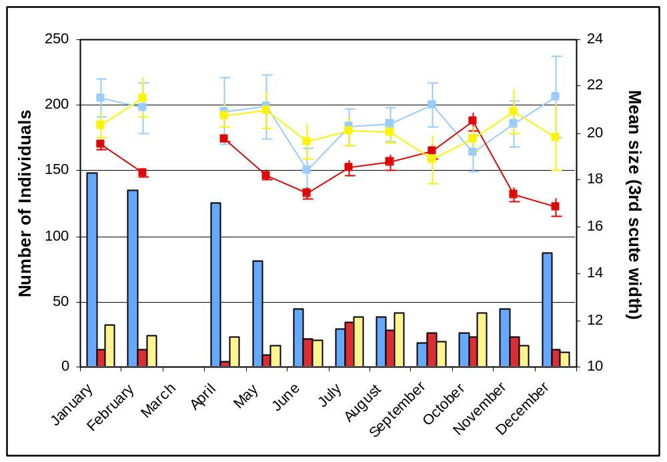

Figure 8: Number of individuals (columns) and mean size (line) as determined by the width of the third scute for the three giant tortoise transects monitored on Grande Terre, Dune Jean Louis and Dune D’Messe.

Population models
In 2004 Rainer von Brandis developed one of the population models available at the station to estimate the population size of the giant tortoise on Aldabra. This model is based on the trends in the tortoise numbers along the different transects (see RO Annual Report 2004 and 2005 for further information). As part of this model the Threshold for Potential Concern (TPC) was estimated. This threshold is primarily based on the trends in overall numbers of tortoises detected along the transects and factors in 1) the number of successive annual declines in tortoise numbers, 2) the percentage of variation in tortoise numbers between years and 3) the correlation coefficient of tortoise numbers over time. The level of concern in regards to the population trends in tortoises is then rated on a scale of one to three with one being no real concern and three being action is required. In 2008 analysis of the tortoise transect data in this model triggered a Level 1 concern (no action required) for 6 of the transects while the remaining 6 had no level assigned to them. The 6 that resulted in a Level 1 concern were Picard Coastal, Picard Back Path, Malabar, Dune D’Messe coastal, Dune D’Messe inland and Dune Jean Louis.

Unfortunately the Aldabran giant tortoise Monitoring Database designed by David Bourn in 2004 is not currently running in a way as to allow up to date population estimates from the data collected and entered. All monitoring data for the giant tortoises are currently entered into this data base as well as into the one developed by Ranier. However, the links in the access data base are mostly out of date and broken and as such this data base can not currently be used to generate population estimates.

Picard Backpath, Picard Coastal, Malabar, CC Coco, DDM Coastal, DDM Inland, DJL all triggered a yes response in the threat analysis at Level 1 – No real cause for concern. All other transects showed a negative answer to all 3 levels of concern included in the threat analysis model.

 | Pic Backpath | Pic Coastal | Anse Var | Malabar | MC Casuarina | MC Inland | CC Groves | CC Coco | CC Coastal | DJL | DDM Inland | DDM Coastal
2000-2001 | 9.62 | 15.56 | 48.16 | 4.98 | 90.63 | 28.11 | 21.46 | 5.21 | 14.37 | 35.29 | 25.94 | 47.76
2001-2002 | 25.59 | 26.94 | 12.71 | 17.54 | 8.44 | 2.61 | 24.80 | 0.19 | 30.46 | 1.40 | 11.93 | 25.70
2002-2003 | 3.04 | 26.04 | 16.21 | 19.02 | 13.49 | 19.49 | 2.95 | 71.09 | 18.42 | 1.11 | 36.86 | 20.93
2003-2004 | 0.22 | 5.13 | 1.42 | 1.95 | 4.67 | 5.85 | 6.59 | 8.61 | 15.94 | 21.88 | 2.00 | 43.92
2004-2005 | 3.41 | 0.67 | 24.48 | 11.69 | 22.38 | 5.52 | 4.29 | 8.85 | 5.54 | 0.64 | 2.86 | 5.27
2005-2006 | 17.77 | 14.24 | 21.30 | 1.71 | 20.57 | 4.31 | 7.65 | 13.83 | 24.23 | 7.10 | 14.72 | 23.51
2006-2007 | 12.15 | 13.04 | 3.05 | 10.65 | 26.62 | 12.39 | 22.95 | 13.18 | 37.64 | 5.21 | 9.73 | 2.73
2007-2008 | 2.81 | 23.64 | 6.67 | 9.73 | 103.92 | 4.71 | 10.64 | 8.69 | 33.03 | 2.93 | 11.34 | 5.93
2008-2009 | 0.00 | 19.49 | 8.73 | 2.76 | 8.65 | 16.25 | 29.37 | 24.66 | 4.87 | 17.74 | 31.92 | 9.17

5.0: Bird Monitoring
There are a number of different monitoring activities undertake on Aldabra to monitor the bird populations. This includes monitoring focussing on land birds, waders and a number of the sea bird species on the atoll.

5.1: Land birds
The land bird monitoring involves seven of the tortoise transects located around the atoll (Figure 1). Along each of these transects point counts are conducted (counts of birds seen or heard over 4 minutes within a 25m radius of a specific point along the transect). The number of points monitored ranges from 4 – 9 depending on the location of the transect. The monitoring of land bird abundance around the atoll at these seven transects has been undertaken since 2002 and continues to provide valuable information, particularly in regards to the abundance of passerines. Point counts were conducted on all seven transects every month during 2008.

The total number of birds recorded across all point counts on all transects is shown in Figure 10 (no Fig. 9 is mentioned). Displayed on a logarithmic scale it clearly shows that the most abundant species was the Souimanga sunbird with the Malagasy turtle-dove the second most abundant species recorded. It is important to note that this figure does not account for differences in abundance between transects but shows the total number of individuals recorded. Despite this the sunbird was indeed the most abundant species across all transect locations. While the Malagasy nightjar was not recorded on any of the transects, most likely due to the methods used and the low detection probability of this species during diurnal surveys.

Figure 11 shows the mean annual total number of birds recorded on the land bird transects from 2002 to 2007. It also shows the total number recorded for each species in 2008 on the same transects. The numbers recorded for 2008 are extremely similar to the average total number recorded for the previous 5 years and indicate no significant decrease or increase in the number of birds detected throughout the year. It does show a slight decrease in the number of pied crows detected at the point counts along the transects although their highly mobile nature could easily influence this along with the methods designed more specifically for passerines. The total numbers recorded for 2008 fall well within the variation in numbers for the previous 5 years. Standard errors were calculated for these totals but are not shown on the graph due to the logarithmic scale used to plot the number of birds recorded.

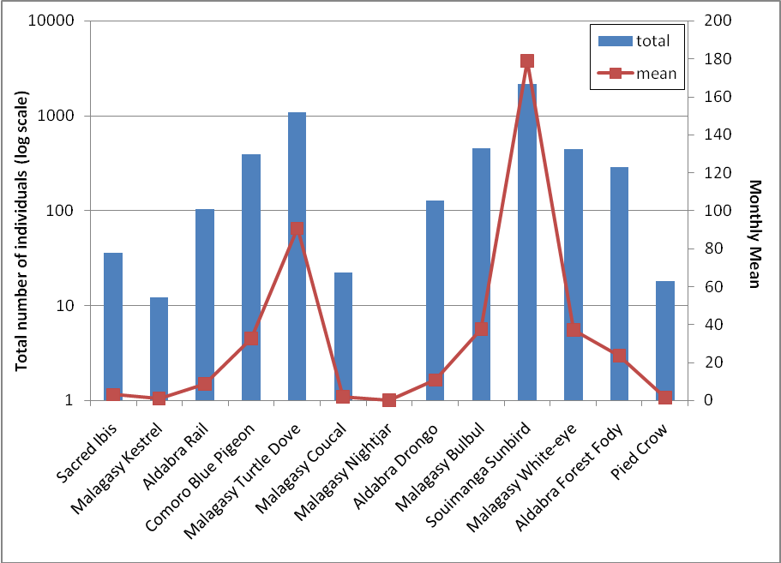
Figure 10 (there is no Figure 9?) : Total number and monthly mean number of birds recorded across all point counts on all transects for 2008.

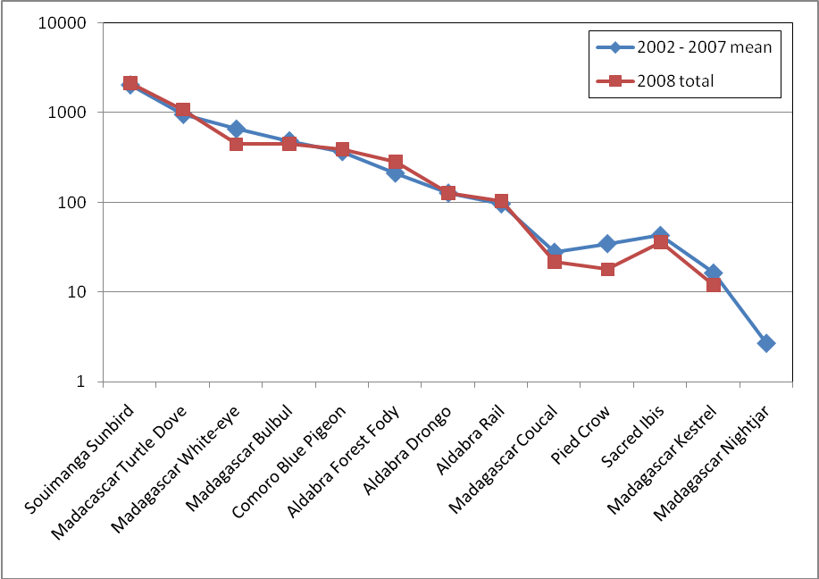
Figure 11: Mean annual total number of birds recorded on the land bird transects during 2002–2007 and total number recorded for each species in 2008 on the same transects.

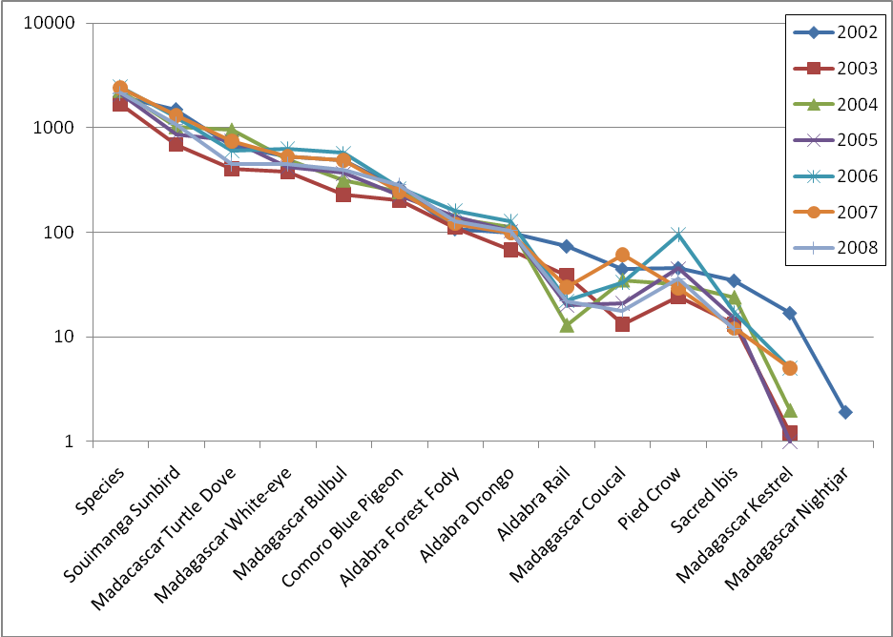
Figure 12: legend? – Also not referred to in text??

Rail Monitoring

Monitoring of the rail populations on the individual islands of Aldabra is not currently undertaken. Previously this monitoring of the rail was conducted at a number of transects with the use of call play back tapes.

As with the previous annual report, the current monitoring of the rail population on Picard is restricted to sightings and counts of individuals recorded during the monthly land bird monitoring. The data gathered on the land bird point counts at the transect on Picard show very little variation in the total number of birds recorded throughout the year. While the numbers for 2008 are higher than the previous year they are slightly lower than others for example 2006 and 2004 (Table 8).

Table 8…
 | 2002 | 2003 | 2004 | 2005 | 2006 | 2007 | 2008
TOTAL | 74 | 67 | 112 | 103 | 127 | 98 | 104

Monthly totals for 2008 and 2007 (Table 9) show similar trends in the number of birds detected. These numbers are not presented for other preceding years as the data files for the land bird counts in previous years require significant editing to allow accurate calculation of values. This is particularly the case for calculation of monthly totals and averages. In point count methods such as these records of 0 birds in a particular species for a particular point along any one of the transects are important data points. These values have previously been excluded from the summaries and calculations of mean sightings and need to be included for an accurate representation of species distribution and abundance. Attempts will be made to rectify this for the next annual report as well as coming monthly reports.

Any trends evident in the monthly numbers and abundance may indicate post breeding increases in the population. These could then be used in conjunction with previous surveys to provide an indication of the most appropriate timing for targeted surveys of the rail populations, as suggested in the previous annual report and following the methods of Huxley.

Table 9…
TOTAL | Jan | Feb | Mar | Apr | May | June | July | Aug | Sept | Oct | Nov | Dec
2008 | 7 | 8 | 8 | 10 | 11 | 9 | 15 | 13 | 7 | 5 | 4 | 7
2007 | 11 | 13 | 10 | 20 | 11 | 3 | 3 | 8 | 4 | 1 | 9 | 5

5.2: Wader counts

Table 10: Wader species and number of individuals seen off Settlement Beach.
 | January 2009 |  | February 2009
 | 20/1/09 |  | 5/2/2009 | 19/2/2009
Crab plover | 30 |  | 13 | 2
Dimorphic egret | 2 |  | 5 | 9
Greater sand plover | 1 |  |  | 2
Lesser sand plover |  |  | 2
Green-backed heron | 5 |  | 7 | 5
Grey heron | 1 |  | 2 | 2
Grey plover | 3 |  | 1 | 5
Ringed plover |  |  | 2
Ruddy turnstone | 73 |  | 67 | 46
Sanderling | 23 |  | 20 | 23
Whimbrel | 2 |  |  | 3
Wood sandpiper |  |  | 1

crab plover

flamingo

5.3: Sea birds

Red-tailed tropicbird (Phaeton rubricauda) monitoring
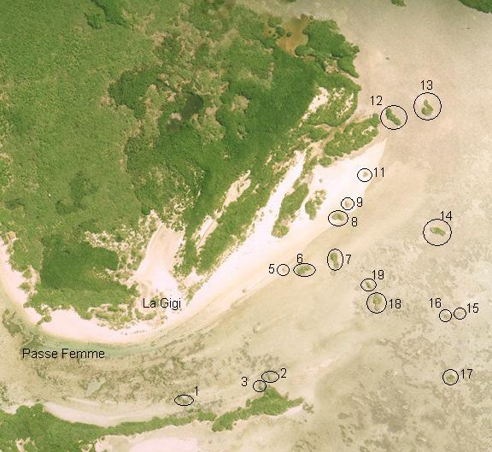

Vagrant and unusual bird sightings

6.0: Subsistence Fishing

Table 12: Details of fishing trips conducted throughout 2008.
Species | Total number of fish | Total weight of fish | Mean weight per fish | Percentage of total catch
Emporers
Baksou | 14 | 9.20 | 0.66 | 0.42
Bawa / Malbawa | 1 | 0.80 | 0.80 | 0.04
Bekbek | 1 | 1.60 | 1.60 | 0.07
Gel Long / Bek Long | 1 | 2.10 | 2.10 | 0.10
Kaptenn Rouz | 135 | 299.15 | 2.22 | 13.53
Madanm Beri | 4 | 3.30 | 0.83 | 0.15
Groupers
Babonn Sesil | 2 | 5.50 | 2.75 | 0.25
Kwasan | 245 | 368.75 | 1.51 | 16.68
Madanm Dilo | 15 | 3.35 | 0.22 | 0.15
Vyey Babonn | 4 | 25.60 | 6.40 | 1.16
Vyey Galfa | 2 | 2.50 | 1.25 | 0.11
Vyey Goni | 4 | 32.50 | 8.13 | 1.47
Vyey Krab | 1 | 4.90 | 4.90 | 0.22
Vyey Masata | 69 | 158.90 | 2.30 | 7.19
Vyey Plat | 73 | 175.20 | 2.40 | 7.93
Vyey Sat | 3 | 5.30 | 1.77 | 0.24
Vyey Toukoula | 19 | 234.40 | 12.34 | 10.60
Vyey Zannannan | 26 | 69.30 | 2.67 | 3.14
Triggerfish
Bours | 5 | 7.50 | 1.50 | 0.34
Wrasses
Snappers
Terez | 3 | 2.00 | 0.67 | 0.09
Varavara | 191 | 352.35 | 1.84 | 15.94
TOTALS | 624 | 1409.85 | 2.26 | 63.78
Trawling
Zob Gri / Zob Ver | 8 | 21.80 | 2.73 | 0.99
Jacks/Pompanos
Galate | 6 | 80.80 | 13.47 | 3.66
Karang Ledan | 42 | 350.00 | 8.33 | 15.83
Karang Ver | 45 | 183.40 | 4.08 | 8.30
Tunas
Bonit | 21 | 128.00 | 6.10 | 5.79
Ton Ledan | 1 | 32.50 | 32.50 | 1.47
Ton Zonn | 1 | 4.00 | 4.00 | 0.18
Barracudas
Tazar | 8 | 136.51 | 17.06 | 6.18
TOTALS | 124 | 800.50 | 6.46 | 36.22

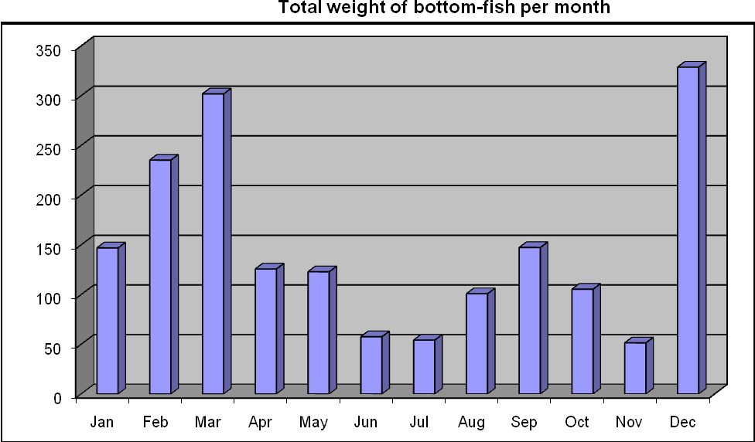

Figure 13…

7.0: Robber Crabs
Robber crab monitoring was first instigated in October 2006 with an increase in the effort invested in this monitoring commencing in March 2007 by the then RO Pierre Pistorius. This monitoring has continued on a regular basis

8.0: Marine Mammals

8.1: Dugongs

8.2: Whales and dolphins

9.0: Vegetation Monitoring

10.0: Goat Eradication Project

11.0: Rangers Projects

12.0: Departmental Issues

12.1: 2008 Staff

Table XX: Name, position and engagement of research staff at the Aldabra Research Station. I think it would be better here to list all research staff throughout the year. For the annual report it doesn’t seem sensible to list where they are now – better to state the time that they were actually present on Aldabra.

Name | Post | Engagement / Location
Naomi Doak | Research Officer | Nov–Dec 2008
Alex Underwood | Senior Ranger | All year
David Boodna | Ranger | XXX-Dec 2008
Stan Denis | Trainee Ranger | XXX-Dec 2008
Ritval Pillay | Exchange Ranger | XXX-Dec 2008
Jennifer Stockdale | Volunteer | Nov-Dec 2008
Rowan Yearsley | Volunteer | Jan-May 2008
Amanda Northrop | Volunteer | Jan-May 2008
Rebecca Scott | Volunteer | Nov-Dec 2008
Bernard Coetzee | Volunteer | Nov-Dec 2008
Anyone else???

5.0: Comments from RO

Tortoise files and models.

Robber crabs

